MS SQL SERVER
Standard Operating Procedures
(SOP)

SQL Server Troubleshooting

Submitted to



By



CIS, Wipro Limited

Document Details

Project Name | Innogy SE
Account | CIS
IT Component/Application Title | SQL Server Troubleshooting
Current Version | 1.5
List of Contributors | Pradipkumar Kansara, Kiran Bhalekar, Ayushi Gautam, Sivakumar Goud, Ayushi Srivastava
Customer Contact Information

Version History
(All revisions made to this document must be listed in chronological order. All revisions must be approved. Review and Approval can be done by an internal source or by the customer)
Version | Date of Revision | Description | Author | Reviewed By | Approved By
1.0 | 29-08-2015 | initial Draft | Ayushi Gautam | Pradipkumar Kansara | Mahesh Keshatwar
1.1 | 04-09-2015 | Document Completed | Kiran Bhalekar | Pradipkumar Kansara | Mahesh Keshatwar
1.2 | 21-08-2016 | Updated document to standard format | Kiran Bhalekar | Pradipkumar Kansara | Mahesh Keshatwar
1.3 | 17-05-2017 | Wipro and Innogy Logo changed | Siva Kumar Goud | Pradipkumar Kansara | Mahesh Keshatwar
1.4 | 18-08-2017 | Updated document to Wipro Standard format with header and footer | Ayushi Gautam | Pradipkumar Kansara | Santosh Badiger
1.5 | 18-12-2018 | Updated the document | Ayushi Srivastava | Pradipkumar Kansara | Santosh Badiger

TABLE OF CONTENT

1. Purpose 1
2. Scope 1
3. Problem Troubleshooting 1
3.1 First Step 1
3.1.1 Problem Troubleshooting Approach 2
3.1.2 Tools 2
3.2 Identify And Fix The Process That Is Initiating The Blocking 3
3.3 T-Sql 3
3.4 Activity Monitor (Sql 2000) 5
Activity Monitor (Sql 2005/ 2008) 6
3.5 Dynamic Management Views 6
3.6 Conclusion 8
3.7 Identify And Fix Long Running And Poorly Performing Queries 8
3.8 Sql Profiler (Sql 2000/2005/2008): 8
3.9 Associating Performance Monitor With Sql Profiler (Sql 2005/2008) 11
3.10 Dynamic Management Views 12
3.11 Identify And Fix The Processes That Entering Into Deadlock 13
3.12 Adding Trace 1204 And 3605 Using Dbcc Command 13
3.13 Adding Trace 1204 And 3605 In Start-Up Parameters (2000) 14
3.14 Adding Trace 1204 And 3605 In Start-Up Parameters (2005/2008) 15
3.15 Identify And Fix The Resource Bottlenecks 16
4. Reference 18

Purpose
This document is prepared for the management and troubleshooting of SQL Server Database administration Services at <Customer Name>.

Scope
This document is prepared for GSMC Wipro sustenance team and provides the concepts of configuring database maintenance plan for the administration of the SQL Server database at <Customer Name>.

Problem Troubleshooting
The methodology applied for the pin-pointing the exact problem during the crises must accommodate for the complete description of the problem itself as being witnessed by the end user. The careful assessment of the problem is very important to decide on the path to be followed for the troubleshooting. It might just be possible that we have to get in touch with the user several times to discuss and understand the pain areas.

The end user and the available on-site database development/administration staff plays an important role during the whole troubleshooting exercise. It is a good practice to speak to different users to know independent views and perhaps for more concise inputs.

First Step
- Login to the server to check the current CPU utilization
- Identify the system processes that are currently running and find out the process which is consuming the most CPU resources.
- If the process is not SQL Server then analyze what is the purpose of that process and investigate the reasons behind its poor performance, seek help from infrastructure team to know more details and conclude.

Assuming that it is indeed SQL Server that is causing CPU to go into high utilization state, investigate further using various tools to identify the exact cause. There can be several reasons for the performance degradation and may be categorized as:
- Blocked processes
- Long running and poorly performing queries (Select+Update)
- Deadlocks
- Resource Bottlenecks
  - CPU bottlenecks
  - Memory bottlenecks
  - Disk bottlenecks
  - Network bottlenecks

Note: CPU/ Memory/ Disk and Network bottlenecks are also known as resource bottlenecks.

It is NOT at all necessary (Not advisable too) to concentrate the focus on resource bottlenecks at the FIRST PLACE, instead the first thing that we should do is to ensure that the processes running within the SQL Server are optimized, in the sense, that they are designed for optimized execution with scalability perspective. For example, a query which is making use of in-efficient cursors to fetch data from an OLTP database will obliviously eat-up the CPU whenever it runs and for the duration it runs.

Moreover, SQL Server architecture is designed to adapt itself to the existing resources and reduces the scope for any manual system level tuning. Hardware upgrades certainly helps to boost performance but their effects are incremental and not very significant.

Note: Resource bottlenecks are generally CONSISTENT and do not happen intermittently.

Problem Troubleshooting Approach
We must begin from the basic investigation and advance further up the order. While all this is being done, it is important that the results of the previous analysis are properly documented to leave no space for any ambiguity.

We will the follow the below mentioned approach:
- Identify and fix the process that is initiating the blocking.
- Identify and fix the queries that are causing the degradation
- Identify and fix the processes that are entering into dead-locks
- If no success is observed, move on to:
  - Identify CPU/ Memory/ Disk and Network bottlenecks
  - Collect and prepare enough data to justify the recommendations for any hardware upgrades

Tools
There are several tools available within the SQL Server and Windows operating system that can be used to isolate and fix the problem and they are to be used in sequence:
- Query Analyzer/ SQL Server Management Studio (SSMS)
- SQL Profiler
- Performance Monitor (Perfmon.exe)
- Dynamic management views (SQL 2005/ 2008)

Identify and fix the process that is initiating the blocking
Take the following steps to identify the blocked processes and to find the process which is causing other processes to get blocked.

T-SQL
  - Issue the following command in SSMS or Query Analyzer. This gives us the list of the blocked processes with the details
SELECT
S2.spid Blocked_Id, S1.spid Blocked_By_Id, S2.lastwaittype, S2.waittime,
S2.waitresource, S2.cmd, S2.loginame, S2.nt_username, S2.Last_Batch
FROM sysprocesses S1, sysprocesses S2
WHERE S1.spid = S2.blocked

  - Using the system stored procedure; this gives us details of system wide processes that are currently holding connection
Sp_who2

Alternatively, we can create or alter the above script for more customizations as needed.
After identifying the blocked processes and the lead blocker, we must also issue the following T-SQL commands to know the exact operation

  - The script below with return first 255 characters of the statement being executed

DBCC INPUTBUFFER (58)

  - We may also use this script for the complete command. This works only with SQL Server 2000 SP3 and above or SQL 2005 onwards and for all processes that are in running state.

DECLARE @Handle varbinary(64);
SELECT @Handle = sql_handle
FROM sysprocesses
WHERE spid = 127
SELECT * FROM ::fn_get_sql (@Handle);
GO

In SQL Server 2005 fn_get_sql is deprecated so in-pace of this we can use the DMV as follows:
SELECT * FROM sys.dm_exec_sql_text (@Handle);

Activity Monitor (SQL 2000)
The activity monitor tool of SQL Server Enterprise Manager can also be used to identify the blocked process as shown in the figure below:

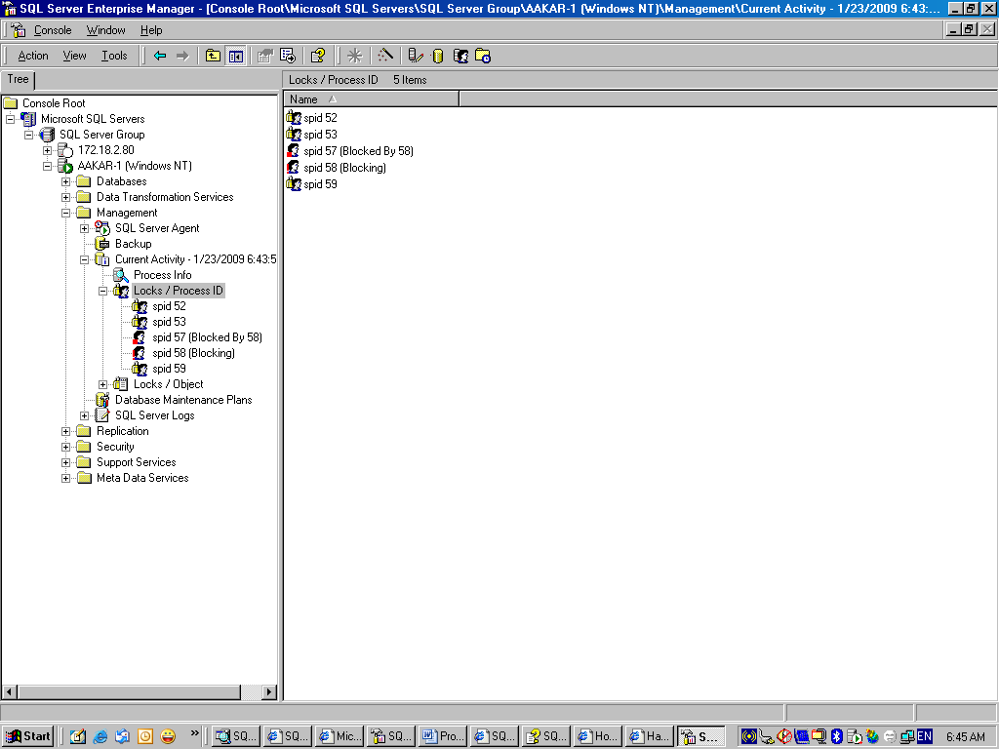

The blocked processes and blocking process items can be double-clicked for the details of the commands that are being executed.

Note: In the background the command that fetches the details is “DBCC INPUTBUFFER”
Activity Monitor (SQL 2005/ 2008)
The activity monitor tool of SSMS can also be used to identify the blocked process as shown in the figure below:

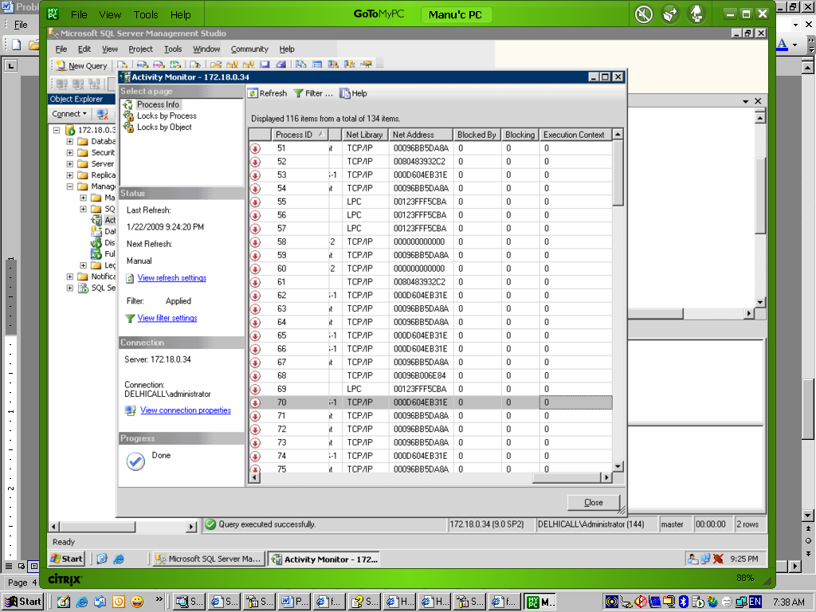

Dynamic Management Views
SQL Server 2005/ 2008 offers several dynamic management views and functions to view the blocking information; some of the important ones are as follows:
- sys.dm_tran_locks
- sys.dm_os_waiting_tasks

Following query can be executed to get the blocking information

SELECT
t1.resource_type,
t1.resource_database_id,
t1.resource_associated_entity_id,
t1.request_mode,
t1.request_session_id,
t2.blocking_session_id,
t3.sql_handle, text
FROM sys.dm_tran_locks as t1
INNER JOIN sys.dm_os_waiting_tasks as t2
ON t1.lock_owner_address = t2.resource_address

Two more DMV/DMF can be applied for relevance of the output in conjunction with sys.dm_tran_locks and sys.dm_os_waiting_tasks
- sys.dm_exec_requests
- sys.dm_exec_sql_text

Following query can be executed to obtain more relevant information:

SELECT
t1.resource_type,
t1.resource_database_id,
t1.resource_associated_entity_id,
t1.request_mode,
t1.request_session_id,
t2.blocking_session_id,
t3.sql_handle, text
FROM sys.dm_tran_locks as t1
INNER JOIN sys.dm_os_waiting_tasks as t2
ON t1.lock_owner_address = t2.resource_address
INNER JOIN sys.dm_exec_requests t3
ON t2.session_id = t3.session_id
CROSS APPLY sys.dm_exec_sql_text (t3.sql_handle)

Conclusion
As we have seen above there are enough commands and tools that are available to point to the process that is being blocked and the one which is leading the blocking chain. They can be tracked and optimized for maximum through-put.

Identify and fix long running and poorly performing queries
Depending upon the environment there can be different thresholds and benchmarks for a query to return the results to the client. In general, any query taking longer than 5 seconds in succession for an OLTP set-up is considered as poorly performing query.

Ideally, we should prefer all queries to respond in <1 second or between 2-3 seconds maximum however situation is different for the system that are reporting based in which case the threshold can vary.

Important, following considerations are kept in mind for long running or poorly executing queries:
- Queries returning large result sets
- Queries not using indexes or not written for using index hints
- Queries that are not written with query hints
- Queries that are using cursors and initiating iterative fetches
- Queries that are calling UDF for achieving the joins

Take the following steps to identify the poorly written and less performing queries

SQL Profiler (SQL 2000/2005/2008):
SQL Profiler trace is one of the most potent tools for identifying the poorly executing queries and easily pin-point the SP/batches and statements that are resource intensive. Using the SQL Profiler on the same server is not advisable as it essentially puts load on the server itself so as far as possible we must runt it on different host. The results must be stored in the table for further analysis.

Note: The trace can also be built using T-SQL command and it causes lesser bottlenecks but using GUI is a better option as it gives you on-screen display and give we an opportunity to match it against the performance monitor as well.

Following events and columns must be selected for analysis purpose:
- Events
  - Stored Procedure
    - RPC:Completed
    - SP: StmtCompleted
  - T-SQL
    - SQL: BatchCompleted
    - SQL:StmtCompleted
    - Batch Completed

- Columns
  - EventClass (mandatory)
  - SPID (mandatory)
  - TextData
  - ApplicationName
  - DatabaseName
  - Reads
  - Writes
  - Duration
  - Starttime

Following figure shows the sample SQL Profiler trace screen. 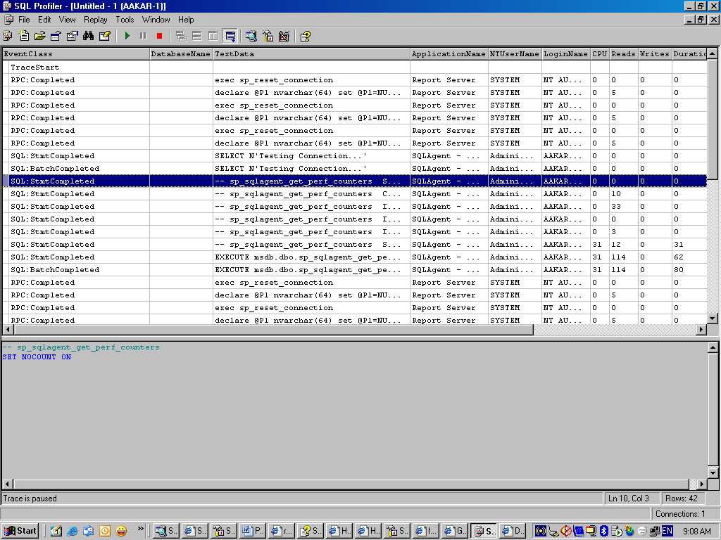

As seen above the SQL Profiler captures and outputs all the events that are happening live in the SQL Server, by noticing the duration, reads and CPU the fair estimation of low performing queries can be made. These queries may then be run individually on Query Analyzer/ SSMS for further optimizations using SHOWPLAN, Estimated execution plan and actual execution plan options.

Associating Performance Monitor with SQL Profiler (SQL 2005/2008)

SQL Server profiler displays data about a large number of SQL Server events. Whereas Windows System Monitor graphically displays information about the server internals. You can merge the two sets of information and walk through a scenario viewing both perspectives using SQL Server Profiler.
To set up the dual-perspective experience, you need to simultaneously capture server performance using both Performance Monitor’s Counter Logs and SQL Server Profiler. The steps to do this are listed below:
- Configure System Monitor with the exact counters you want to view later. Be sure to get the scale and everything just right. Set up the Counter Log to the exact same configuration.
- Configure Profiler with the right set of trace events. They must include the start and end time data columns so that Profiler can integrate the two logs later. Save the profiler and close profiler.
- Manually start the Counter Log. Open SQL Profiler trace code to start the server-side trace.
- When the test is complete, stop both the counter Log and the server side trace. You need to stop the SQL Profiler which is a negative point in this.
- Open profiler and open the saved trace file.
- Use the File->Import Performance Data menu command to import the Counter Log. You have the option of selecting only the important counters from the performance monitor. There will be performance issues if you select too many counters.

Dynamic Management Views
SQL Server 2005/2008 offers several dynamic management views and functions to analyze and fine tune the queries. Following DMV and DMF can be used together to obtain some useful information.
- sys.dm_exec_query_stats
- sys.dm_exec_query_plan
- sys.dm_exec_sql_text

The DMV sys.dm_exec_query_stats returns aggregate performance statistics of the cached query plans. Some of the important columns in this view are:
- sql_handle
- plan_handle
- execution_count
- last_execution_time
- min_worker_time
- max_worker_time
- total_worker_time
- min_elapsed_time
- max_elapsed_time
- total_elapsed_time

Following queries may be executed in SSMS to obtain useful information:

1. SELECT * FROM sys.dm_exec_query_stats order by execution_count DESC

2. SELECT min_elapsed_time, max_elapsed_time,
(Total_elapsed_time/execution_count)/1000/1000 as average_elapsed_time
FROM sys.dm_exec_query_stats

3. SELECT
Text, min_elapsed_time, max_elapsed_time,
(Total_elapsed_time/execution_count)/1000/1000 as average_elapsed_time
FROM sys.dm_exec_query_stats qs
CROSS APPLY sys.dm_exec_sql_text (qs.sql_handle)
-- The above query will attach the SQL Statement associated with the cached query plan

4. SELECT * FROM sys.dm_exec_query_stats qs
CROSS APPLY sys.dm_exec_query_plan (qs.plan_handle)
-- The above query will attach the plan associated with the SQL Statement

Using the above queries we can easily conclude the most cost effective and most time consuming queries. Also by analyzing the query plan the determination for further optimization can be made.

Identify and fix the processes that entering into deadlock
A Deadlock occurs when there is a cyclic dependency between two or more threads for some set of resources. In a dead-lock situation the SQL Server decides and declares the transaction as a deadlock victim based on the amount of work done by them and subsequently returns the error code 1205 to the application. The application must catch these exceptions and re-submit the batch.

Deadlocks can not be eliminated completely but can be reduced using the set rules and principles, for example:
- Submitting transactions in small batch
- Accessing objects in the same order across all transactions
- Avoiding any user input during the transaction
- Using a low isolation level.

These recommendations are needed to be followed while designing the application and as a best practice. The identification of the dead lock involves adding the TRACE flags either in the start-up parameters of SQL Server or by using DBCC Commands. The trace flags 1204 and 3605 are needed for capturing the dead-locks. The trace flag 1204 is used for returning the type of locks participating in the deadlock and the current command affected. The trace flag 3605 on the other hand routes the trace output to the error log.

Adding Trace 1204 and 3605 using DBCC command
DBCC TRACEON (1204, 3605, -1)

The above will apply the trace flags at the global level. The DBCC command is preferred over adding trace flags in the start-up parameters as it does not require the SQL server service to be restarted.

Adding Trace 1204 and 3605 in start-up parameters (2000)
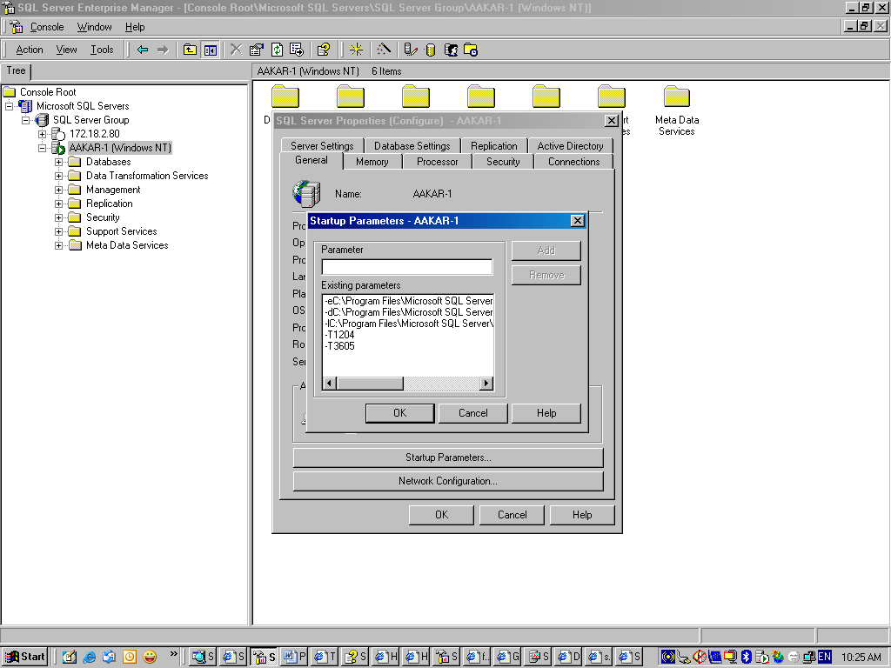

Adding Trace 1204 and 3605 in start-up parameters (2005/2008)
In SQL Server 2005/2008 the start-up parameters are found in SQL Server configuration manager as shown in the figure below:

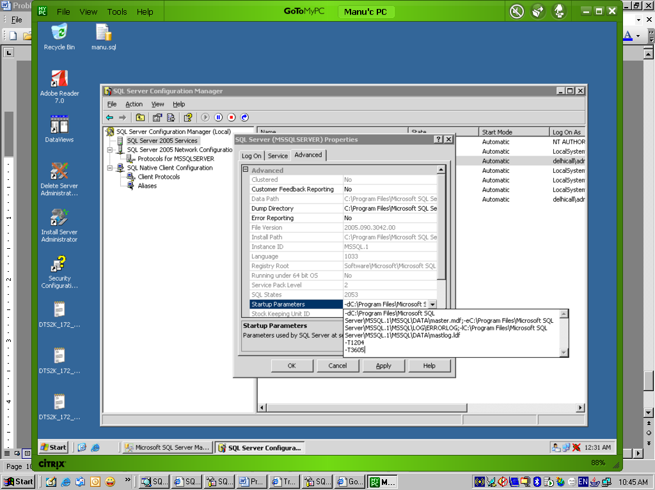

Note: Adding the trace flags in SQL Server 2000/2005/2008 start-up parameters requires the SQL Service to be restarted.

Identify and fix the Resource Bottlenecks
Identifying and fixing the resource bottlenecks is carried through performance monitor (also known system monitor) tool. The performance monitor tools offer several counters that can be measured to gauge the overall performance of the whole server.

The counters must be measured on 24hour period before concluding any reason, the measurement must be done during the production days. The 24 hour period will give us a fair chance to make the assessment of the system.

Once we have captured 24 hours of System Monitor data in a log, display the recommended counters in the Graph mode of System Monitor, and then record the average, minimum, and maximum values in the table format given below:

Counter | Minimum | Average | Maximum | Recommendations/ Explanation
Memory: Pages/sec |  |  |  | This counter describes the number of times the pages are placed from DISK into RAM (Paging-In) or number of time pages is placed out of RAM to DISK (Paging-OUT). This figure must lie between 0 and 20. Higher value means that SQL Server is busy moving the pages. If the counter is displaying higher value (Average) then it dictates that server is having memory bottleneck and more RAM is needed.
Memory: Available Bytes |  |  |  | This value should always be greater than 5MB. Values lower than or near this indicate that SQL Server is having memory bottleneck. Either we have to increase the RAM or reduce load on the server.
Physical Disk: % Disk time |  |  |  | This indicates how busy our physical array is. The rule is that this value should be less than 55%, if this value moves around 55% continuously for 10 minutes or for 24 hour then we must conclude that the SQL Server is having disk bottleneck. In such a situation we must find ways to reduce IO or decrease the workload. Indexes help a lot for keeping this value to the lower level.
Physical Disk: Avg. Disk Queue Length |  |  |  | Like %Disk time, this counter must also be monitored to single out the disk bottlenecks. The value must be less than 2. If this value increases for 10 minutes or for average for 24 hour, we should be sure that the SQL Server has some serious disk bottlenecks. This values needs to be calculated by dividing the Disk queue length value with number of physical disk present in the array. For example 10/6 = 1.66, assuming average disk queue length is 10 and number of physical disk is 6.
Processor: % Processor Time |  |  |  | This counter dictates the percentage of time the processor is busy with completing the requests, values greater than 80% for a period indicates the CPU bottlenecks. Reducing load, optimizing queries, faster processors with L2 cache can help solve the problem.
System: Processor Queue Length |  |  |  | The processor queue length over 2 for each processor also indicates CPU bottlenecks. This must be calculated per CPU, for example, for a 4 CPU box, the processor queue length must not increase 8.
SQL Server Buffer: Buffer Cache Hit Ratio |  |  |  | Buffer cache hit ratio must be greater than 90%. We must achieve 99% buffer cache hit ratio and values between 90%-99% is a good reason to buy more RAM which should definitely be done in case it goes lower than 90%.
SQL Server General: User Connections |  |  |  | This shows the number of user connections. If this value exceeds 255, we must then change “Maximum worker threads” setting to contain higher value. The SQL Server starts sharing the worker threads between the user connections in case the worker thread setting is lower that the actual number of user connections.

Note: The decision based on performance counters must only be made after thoroughly ensuring that processes running within the SQL Server are optimized enough.

Reference
- http://msdn.microsoft.com/en-us/library/aa952081(v=BTS.70).aspx

